**Awards and Honors**

Queen Anne knighted Newton  
  
Was President of the Royal Society  
  
Was an associate of the French Academy of Science  
  
A MP. (Member of Parliament) for Cambridge University  
  
Warden of the Royal Mint  
  
Fellow of Trinity College, Cambridge  
  
Lucasian professor of Mathematics

**Bibliography**

Hall, Alfred Rubert. "Isaac Newton's Life." *Isaac Newton's Life*. Encarta, 1998. Web. 03 Dec. 2012. <http://www.newton.ac.uk/newtlife.html>.

Ipsen D.C. Isaac Newton Reluctant Genius. New Jersey: Enslow Publishers Inc. 1985

**Isaac Newton**

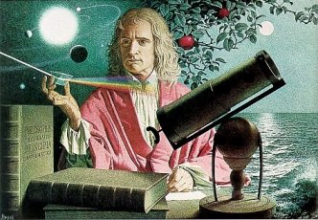

**A Man of Physics**

**Known for his numerous and remarkable accomplishments. These include:**

* **Made the laws of physics**
* **Discovered that white light is made of the colors of the rainbow**
* **Contributed to all branches of mathematics that he studied**
* **Wrote the book, *Principia***
* **Many more**